The Photodecomposition of Bupropion Hydrochloride
College of chemistry and Chemical engineering of Southwest University ,Chongqing ,China
Student Researcher :Min Zheng
Research Advisor: Dr. Michael Ross
Chemistry Department of The College of Saint Benedicts & Saint John’s University

Abstract
Photolysis studies on bupropion hydrochloride were conducted outside using natural sunlight. The investigation used natural water collected from East Gemini Lake (EGL) and buffered e-pure water to determine the dominant photodegradation mechanism in these systems. HPLC analysis determined that bupropion hydrochloride’s photodecomposition via direct photolysis is pH dependant. A PNA base actinometer was used to measure the sun’s intensity in a standardized way alongside the photolysis experiments. This method allowed for the half-life of the photoreaction to be determined.

Introduction
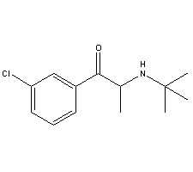
Bupropion Hydrochloride is an antidepressant that is prescribed in therapeutic doses of 200-400 mg per day (100-200 mg tablets; 2 doses per day). It administered orally in the treatment of depression and as an acid in the cassation of tobacco smoking ,though to inhibit neuronal uptake of serotonin , norepinephrine , and dopamine in the central nervous system .It is a form of Personal care products (PCP) that is in an emerging class of aquatic contaminants that have been increasingly detected in field samples, primarily and most recently in the United States. PCPs are a class of chemicals that are continuously released into the environment through human activities.

Figure 1.Structure of bupropion hydrochloride

Experimental Procedure:

Instruments
Chromquest 4.0 Thermo Finnigan UV/VIS detector ,Thermo Finnigan Bupropion Surveyor , Thermo Finnigan Autosample , Thermo Finnigan LC pump. Thermo Electron corporation Orion 3 Star pH Benchtop ,Monobloc weighing technology AB204-s.
Reagent
Bupropion Hydrochloride (trc-20030407 Toronto Research Inc.2) , Formate Acid , Acetate Acid, Ethanolamine ,East Gemini Lake Water ; 0.1M Ammonia , 0.1M HCl ; Pyridine (UN 1282) (PYR) ;4-Nitroanisole (97%) ;E-pured water.
Sample Preparation
0.4532 g Formate Acid was dissolved it into 900 mL E-pure water . And 0.1M Ammonia and 0.1M HCl were used to make sure the pH is 3^{[1]}.Making the pH5 and pH9 buffer in the same way .
Bupropion samples were prepared in pH9、pH5、pH3 buffer and EGL water in concentrations of 100μM. All the solutions were filtered using a motor powered filter system using 0.45µ and0.2µ filter paper.
Photolysis Preparation Setup
Quartz test tubes were used to run all of the photolysis experiments. For outdoor photolysis, the test tubes were placed on a black rack exposing them to sunlight at a 45° angle. The first set of quartz test tubes were covered in tin foil to block out the sun light. This acted as a control. Photolysis experiments were run outside of the Ardolf Science building. Sampling occurred at 0 min, 15 min, 30 min, 1 hr, 2 hrs, 4 hrs and 8 hrs. The samples were pipetted into labeled amber vials at their respective time intervals and capped for future analysis by HPLC.

The method for analyzing the photolyzed samples containing bupropion included a Synergi 4μ MAX-RP 80A, 150 x 3.00mm 4μ micron column for the stationary phase and mobile phase changed as follow(table1):

time | CH3CN% | pH3 Formate buffer% | flow rate mL/min
0.01 | 22 | 78 | 0.8
1 | 22 | 78 | 0.8
3 | 30 | 70 | 0.8
4 | 50 | 50 | 0.8
4.2 | 85 | 15 | 0.8
10 | 85 | 15 | 0.8
Table 1 the mobile phase for the HPLC

The HPLC was set at dual wavelengths of 250 and 300 nm with a run time of 10 minutes. Under these conditions the sample would elute at 5.395 minutes.

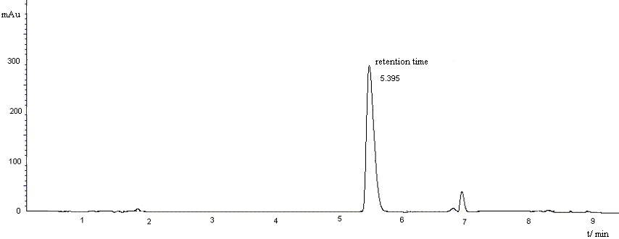
Figure2 the chromatogram of bupropion
Results
It was determined that bupropion photodecomposed by direct and photolysis and also showed a dependency on pH.

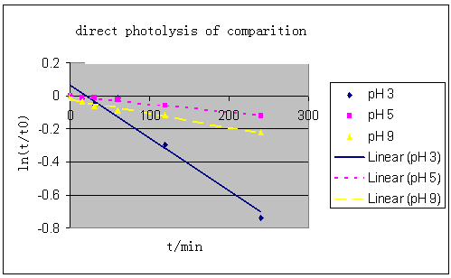
Figure 2: The direct photolysis of bupropion in different pH Buffer.

Figure 4: Comparison of direct and dark photolysis of bupropion.

The half-life time of photolysis of bupropion also changed by pH

 | direct Photolysis | Photoreaction rate constant κdc(day-1)
pH 3 Formate Buffer | 1.47hrs | 11.32
pH 5 Ammonium Acetate Buffer | 11.52hrs | 1.45
pH 9 Ethanolamine Buffer | 5.39hrs | 3.08
East Gemini Lake Water | 1.62hrs | 10.31
Table 2 The half-life time of photolysis of bupropion in different pH

According to the half-life chose Actinometer- PNA to adjust the rate of the actionmeter to equal the rate od the test chemical.And got the half-life of bupropion photoreation.in EGLwater during summer.^{[2]}
PNA-PYR Photoreaction rate constant Κa=8.52
Κdc/ Κda=10.31/8.52=1.21
Φda=0.0169[PYR]
=0.0169×[1.04(Κdc/ka)-0.000645]
Ka=5030 day-1 at latitude 40 in summer (<The kinetics of environmental aquatic photochemistry>).So Φda=0.00029
Φdc=(1.21)(5030/9.96)(0.00029)
=0.018
For summer Κde =0.018(13.0) =0.234 day-1
For summer t(1/2)E =24×o.693/(0.234×2.2)=3.32hrs
Discussion
1.The wave length choice
Bupropion sample was dissolved in E-pure water which was scanned by a UV detector..There were two absorbing peaks.They were laying in 250 nm and 300 nm.As a result , the UV detector was set up at dual wavelengths of 250 and 300 nm
2.The rack should be black
The black rack which Quartz test tubes were placed on should be black.Because all samples must be kept from reflection . It was a study of derict photodecomposition of Bupropion
Reference:
[1].http://www.liv.ac.uk/buffers/buffercalc.html
[2].Leifer,Asa.The kinetics of environmental aquatic photochemistry . (1988):119-138.

