Plants and Human Affairs – Biology 106 name ______________________
Plant Portrait

- Scientific Name: ____________________________________
- Common Name: ___________________________________
- Family name (technical):_____________________________
- Family Name (common): _____________________________
- Growth habit: tree shrub herb vine
- Part(s) of plant used:
- Description of economic uses:

- Cultivation Techniques:

- Product Preparation:

- Miscellaneous:

- Region of presumed origin (indicate on map):

- Current area of cultivation (indicate on map)
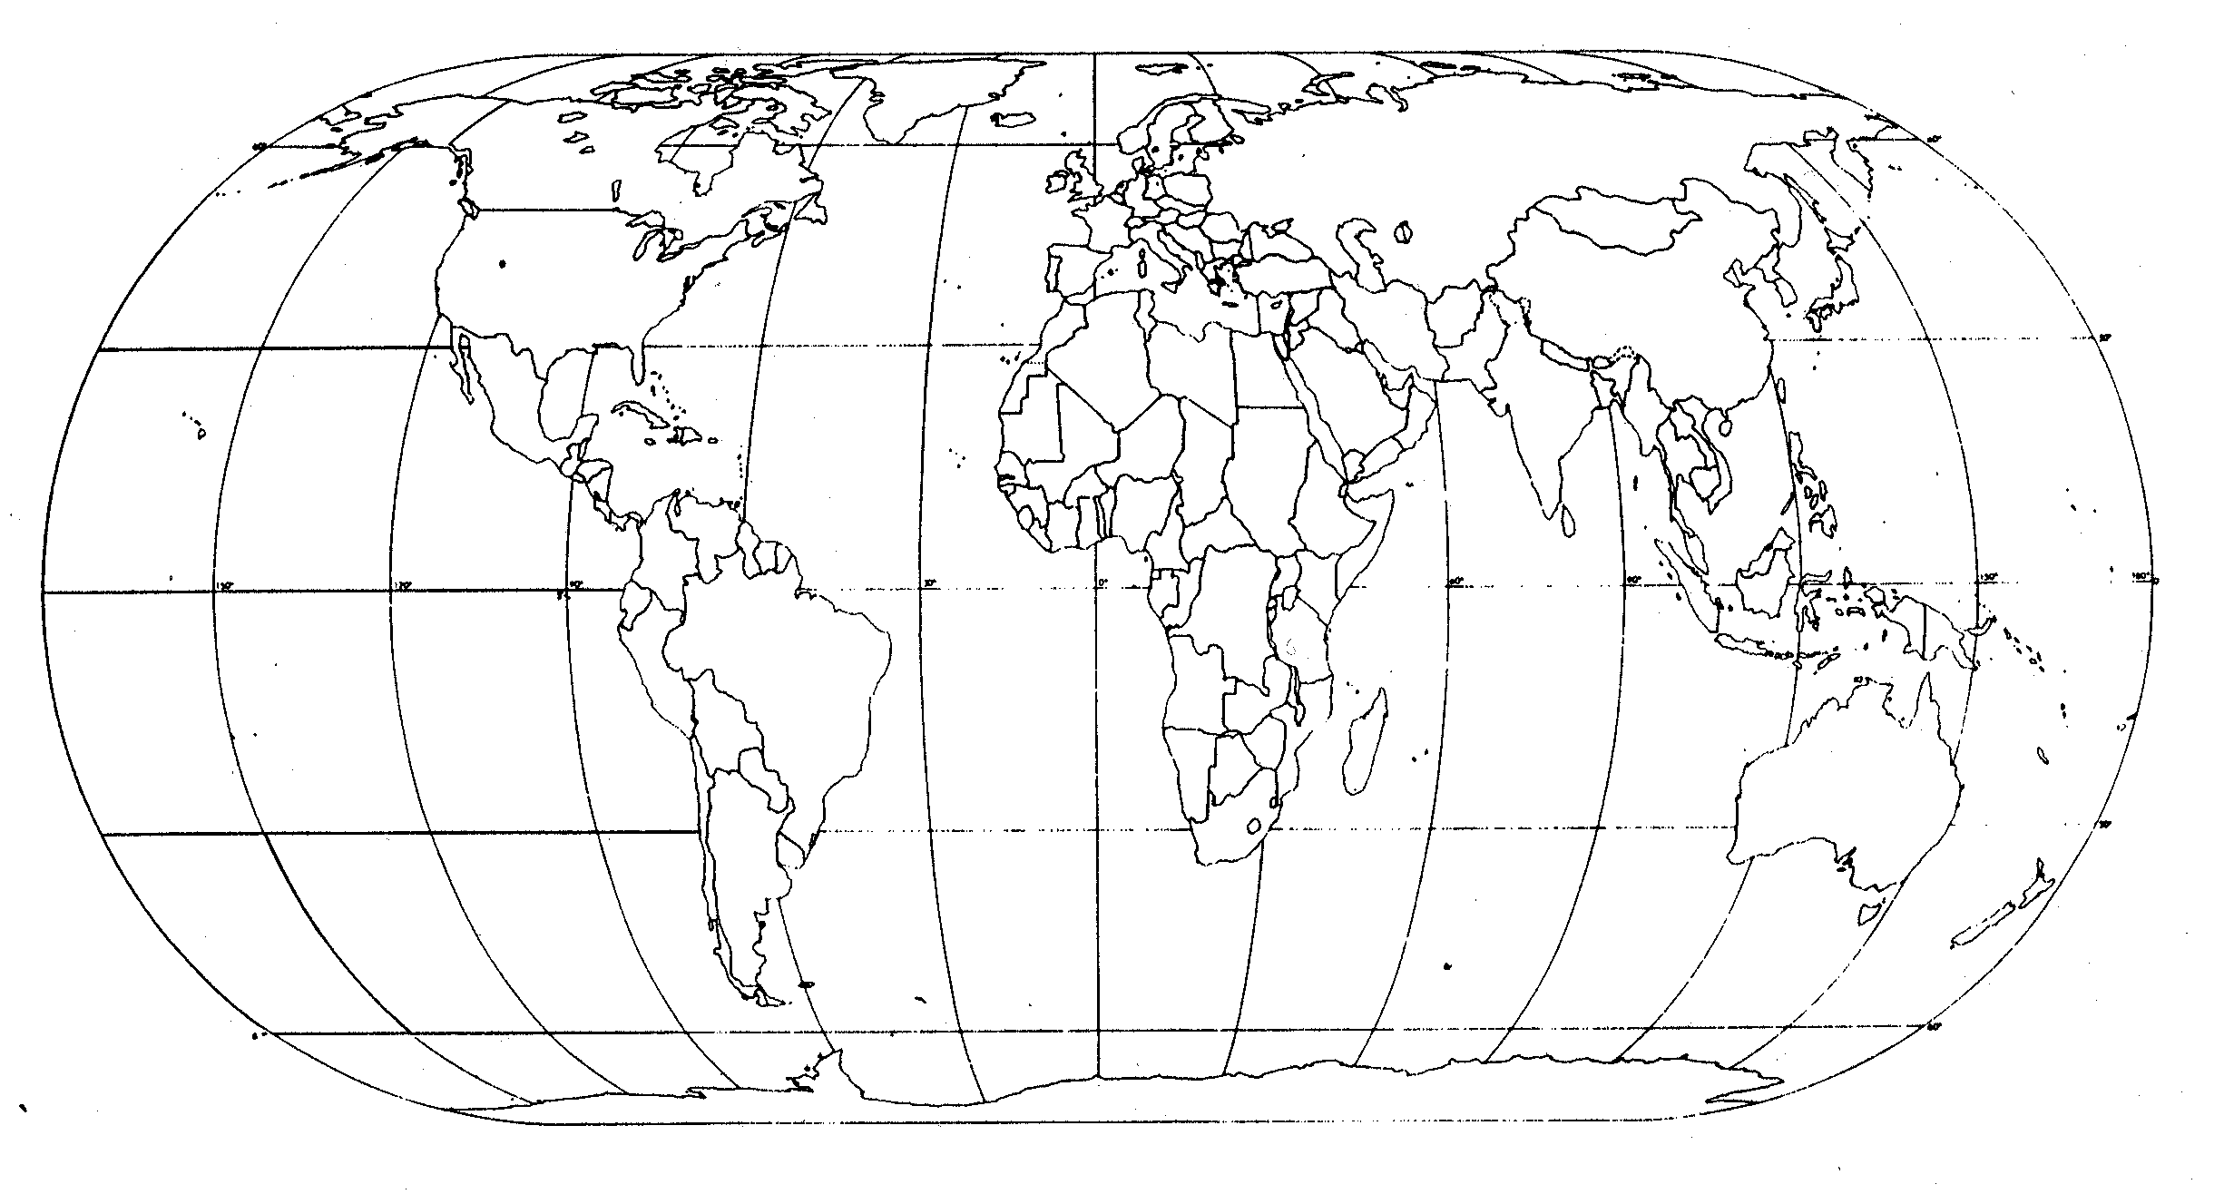
- Photo/Diagram/Sketch:

- References:

